Year 8 Science Units 6 & 7

How to use this Workbook

This Workbook is NOT designed for printing out. It needs to be added to as we proceed through the unit.
Hard copy worksheets for use in class will be supplied as needed.
Put your name in the header immediately and save the file to the Science section of your iFolder.
Use it for all your work, saving it as a new version frequently.
Compress any photos or pictures to web format to keep your file size small. Ask a friend if you don’t know how.
Submit it electronically regularly using the Workbook in Progress Hand-in facility on the Intranet.
Everyone must complete the Journal section to the best of their ability
Everyone must complete the Experiment section.
Everyone must do the Remember and Think Activities
You may choose whether or not you do the ‘digging deeper’ activities
You may use the Chemistry Discussion Forum to get help or discuss chemistry with your colleagues and /or your teachers.
Contents

Journal Section
Experiment Section
- Properties of Materials
- Investigating solids liquids and gases
- Changing the boiling point of water
- Investigating diffusion
- Expansion and contraction in gases
- Cohesive (‘sticky’) properties of water
- Flaming atoms
- Elements and compounds
    - making a compound (demonstration)
    - collecting an element
    - building MolyModels
- Chemical Changes I
- Chemical Changes II
- A useful precipitation reaction
- Preparation of a plant indicator
- Testing for acids and bases
- Combustion reactions
- Rates of reaction
- Increasing the rate of reaction with a catalyst (demonstration)
Formal Report Section
Homework Activities
Journal Section
You need to keep your Journal during each lesson and after the lesson as part of your homework.
The table below covers one week of lessons. You may keep a Journal in your own format as long as it contains the headings.
To add a section for the next week:
- copy the whole table
- insert a new page by typing Ctrl + Enter (Inserts a new page)
- Type Ctrl + V to paste in the table for the next week into the new page.
- Take care to keep each section together.

Journal for the week beginning : Insert the date
Date | What we did today (In class notes) | Write here. Include any drawings you have made, or pictures that have been taken
Date | What I thought about my observations | Write here
Date | What I learned | Write here
Date | What I would like to find out now | Write here
Date | What we did today | Write here
Date | What I thought about my observations | Write here
Date | What I learned | Write here
Date | What I would like to find out now | Write here
Date | What we did today | Write here
Date | What I thought about my observations | Write here
Date | What I learned | Write here
Date | What I would like to find out now | Write here
Date | What we did today | Write here
Date | What I thought about my observations | Write here
Date | What I learned | Write here
Date | What I would like to find out now | Write here

Experiments: Data (Tables, Notes and Observations)

Experiment 1: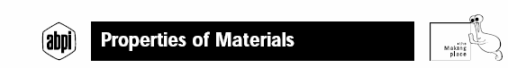

Date Co-workers

Aim: To investigate some properties of materials

Materials and methods:
Collect together some objects that are made from different materials.
- ball
- cup
- glass,
- rubber
- glove,
- sea shell,
- wooden spoon
- metal fork
- plastic ruler
- wool etc
Pick them up and feel them.
Can you think of words that describe them?
Some of these words will describe more than one object. Put all the things that are described by one word in one group (for example all the "soft" things). What word describes the things left over? Now repeat twice with other words.
List all your objects. Tick the words that describe them in the table below.
Can you think of the opposite words?
The words that describe materials are their properties. These are things that do not change unless you change the material.
(Big & small are not properties as you can cut materials to make them smaller).

 | Property | flexible | hard | magnetic | transparent | elastic | electrical conductor | strong | absorbent
Objects
(Add more rows as needed)
 | Opposite Property | stiff | Soft

WOULD YOU MAKE: | No? What property is needed? | What would be a good material?
A METAL window? | transparency | glass
A STRING chair?
A PLASTICINE knife?
A PAPER bucket?
A PLASTIC magnet?
A METAL overcoat?
A GLASS football?

Experiment 2: Investigating solids, liquids and gases

Date Co-workers
Aim: To investigate the properties (characteristics) of solids, liquids and gases)
Materials:
- a piece of dowel
- large plastic syringe
- water
- plasticine
- salt
- sponge
Methods:
- Place the dowel in the syringe. Press down on the plunger.
- Draw some water into the syringe. Place your finger over the end of the syringe and press down on the plunger.
- Draw some air into the syringe. Place your finger over the end of the syringe and press down on the plunger.
- Complete the remainder of the table by looking closely at the dowel and water, and by reading the captions on the circus diagram.
- Investigate the properties of plasticine, salt and sponge.
- Place them in the appropriate column based on your observations.
Safety Considerations you may not start this experiment until your group have completed this
List the actions you took to ensure safe practice and safe disposal.

Property | Solid  Dowel | Liquid  Water | Gas  Air
Questions:
Can the dowel be compressed?
Can water be compressed?
Can air be compressed?
Which materials did you have trouble classifying? Why?
Experiment 3 p. 5: Changing the Boiling Point of Water

Date Co-workers

Aim:
To determine the boiling point of water and to investigate what happens to the boiling point when varying amounts of the same substance are dissolved in water.
Materials
List what you used
Method
Describe what you did. A diagram may help. Draw your own or copy and paste from your CD.
Safety Considerations you may not start this experiment until your group have completed this
List the actions you took to ensure safe practice and safe disposal.
Results:
Record your results in this table, or replace it with the table and graph from the downloaded ‘Salty Water Excel Graphing file’
 | Temperature Changes
 | Time (min)
Amount of Salt added (tsp) | 0 | 1 | 2 | 3 | 4 | 5 | 6 | 7 | 8 | 9 | 10
0
2
4
6

Discuss your findings here or in your Journal
Experiment 4: Investigating Diffusion

Date Co-workers

Aim: To investigate the movement of dissolving substances through a liquid and of perfume through air.

Materials and Methods:
As described on p. 7 of Science Alive 2, except that the potassium permanganate was replaced with Instant Coffee powder.

Safety Considerations you may not start this experiment until your group have completed this

Answers to Questions

- Diagram of movement of coffee in water

Draw in Paint or Fireworks and copy and paste here

- Observations of movement of perfume in room

- Reasons for observations
Experiment 5: Expansion and contraction in gases
Date Co-workers

Aim: To Predict, Observe and explain what will happen in the following scenarios
Safety Considerations you may not start this experiment until your group have completed this

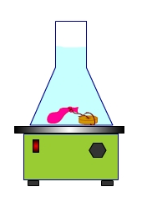  - A water balloon with a small amount of air is tied off, attached to a 50 g mass and placed in a flask and heated on a hotplate as shown above | Prediction  Observation  Explanation
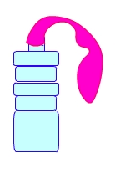  - A normal balloon is placed on an empty drink bottle as shown in the diagram. The bottle is placed firstly  - in a container of hot water for 5 – 10 minutes and then  - in a container of ice cold water for 5-10 minutes | Prediction  Observation  Explanation

Experiment 6 pp. 12-13 + extra material
Date Co-workers

Aim: To examine some of the cohesive properties of water

Materials and Methods

Task 1
Bread tag boats  - Obtain a clean margarine or ice cream container  - Add enough tap water to half fill the container  - Place your bread tag at one end of the container and add a drop of detergent as shown in the diagram  - Observe and describe what happens  - Can you explain it?  Write here or in your journal | 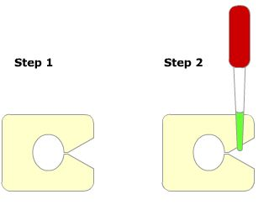
Task 2
Float a pin
- Follow the instructions in ‘What about water’ on p. 13 of your text book
- Describe and explain what happens
Write here or in your journal
Task 3
How many drops of water can you put on a 5 cent piece?  Have a competition using a dropper | 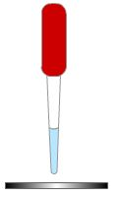
Experiment 7 p. 17 Flaming Atoms

Date Co-workers

Aim: Read the instructions on p. 17 and write your own

Materials and Methods
As described on p. 17

Safety Considerations you may not start this experiment until your group have completed this

Results (Observations)
Metal Tested | Flame Colour and other comments
Barium
Strontium
Copper
Potassium
Nickel

Answers to Questions
- Each of the substances you have tested is made up of a metal and chloride. How do we know that it is the different metals that produce a different colour and not the chloride?
- How can a flame test be used to identify atoms?
- Why do you need to clean the wire loop between each test?

Experiment 8
Part A ‘From elements to compounds’ p. 19 as a Demonstration

Aim To compare the difference between the two starting materials oxygen and magnesium and the product they combine to form
Materials and methods as described on p. 19
Safety considerations
Your teacher will do this experiment behind a screen and it will be projected onto the Screen/TV using a Flexicam video system
You WILL NOT look at the actual reaction because of the risk of eye damage!

Results/Observations
Write here
How did the magnesium change?
What colour was the burnt magnesium?
The burnt magnesium is a compound. What element in the air did it combine with?

NEW!! Word equation
Try to write a word equation for what happened.
Reactants (the ingredients you started with) |  | Products (what was made)
 | →

Part B ‘Collecting an element’
Aim to prepare a sample of the element hydrogen and to observe the test for this element
Safety Considerations you may not start this experiment until your group have completed this
List the actions you took to ensure safe practice and safe disposal.
Materials and Methods
- Safety glasses  - Lab coats  - Gloves  - Test tube rack  - Test tubes  - 1 M HCl (hydrochloric acid)  - A small measuring cylinder  - Small pieces of magnesium metal  - Matches  - Wax taper  - Measure 5 mL of hydrochloric acid and pour it into a test tube.  - Add ONE piece of magnesium and place a second test tube on top of the first as shown in the diagram. Carefully observe what happens.  - After a few minutes lift the inverted (upside down) test tube up from the first one, keeping it upside down.  Have one person in the group place a lighted taper near the opening of this test tube. |  | 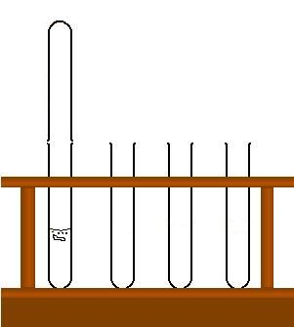
Describe what happened in the test tube.
The gas you collected is hydrogen
Describe its colour. Was there an odour?
Look closely inside the second test tube and describe what you see.
You have just observed the test for hydrogen. What ‘nickname’ could the test have?
Can you write word equations for
- The initial reaction
- The last reaction
Building models of molecules using MolyMod sets

Aim to increase our understanding of the differences and similarities of atoms, elements and compounds

Materials

MolyMod kits 1 set per table. Thank you for taking care to return complete sets after you finish, and for checking the floor around you for escaped bits.

Substance | contains atoms of | Element? | Compound? | Molecule? | Formula | Drawing of model
Carbon Dioxide | Carbon,  Oxygen (2) |  |  |  | CO₂
Methane | Carbon  Hydrogen (4)
Hydrogen | Hydrogen (2)
Oxygen | Oxygen (2)
Water | Hydrogen (2)  Oxygen
A mixture | Choose two of the above
At the end of this activity, use your new knowledge to complete the table
 | Elements | Compounds
Similarities
Differences

Experiment 9 Chemical Changes I
Date Co-workers
Aim: To investigate how you can tell a chemical reaction has taken place
Materials:
- 110g sugar
- 150 mL cold water
- 500 mL beaker
- Hotplate
- Stirring rod
- 220 °C thermometer (Candy Thermometer)
- Test tube
- Patty pans
- Heatproof mat
- Electronic balance
- Measuring cylinder
- 2 teaspoons of golden syrup
- Half a spatula of cream of tartar
- Half a spatula of bicarbonate of soda
- Laboratory coat and safety glasses
Method
  - Mix the sugar, cold water, golden syrup and cream of tartar in the beaker.
  - Gently heat and stir the mixture over the hotplate until the sugar has completely dissolved.
  - Stop stirring the mixture when it boils.
  - Allow the mixture to reach 154 °C, and then remove it from the hotplate.
  - Dissolve the bicarbonate of soda in 1–2 mL of warm tap water in the test tube. Pour the dissolved bicarbonate of soda into the sugar mixture, stirring gently.
  - Pour the hot mixture into patty pans.
  - Allow to cool before examining.
  - What evidence is there that a chemical reaction has taken place?
SAFETY CONSIDERATIONS:
The beaker and the mixture are very hot. Remove them from the hotplate with care.
DO NOT eat the product unless we have been able to use the Mothers’ Kitchen
Experiment 10 Chemical Changes II
Date Co-workers
Aim:
Perform the following experiments to determine what observations indicate a chemical change has taken place.

Hypothesis:
How do we know a chemical change (reaction) has taken place?
Expanding table

Part 1
Materials:
  - 2 pieces of copper wire
  - Vinegar (Acetic acid C₂H₄O₄)
  - 100 ml beaker
  - Power pack
  - 2 connecting wires with a banana clip and alligator clip on each.

Procedure:
    - Connect the wires to the (+) and (-) terminals of the power pack and connect to one piece of copper wire each.
    - Place the 2 copper wires in the beaker with enough vinegar to cover the bottom 2 cm of the copper. Make sure the two pieces of copper wire do not touch. (The alligator clips can clip onto the edge of the beaker)

    - After a few minutes, record your observations. Leave the experiment run for 5 minutes. Are there any other changes?

Expanding table
Part 2
Materials:
- Baking soda (Sodium bicarbonate NaHCO₃)
- Vinegar (C₂H₄O₃)
- 100ml beaker
- Spatula
- Stirring rod

Procedure:
Note: Do this at the sink as it may overflow
Place 50ml of vinegar into the beaker and add two spatulas of baking soda and stir with the stirring rod.

Observations:
Expanding table

Part 3
Materials:
2 test tubes
Test tube rack
Silver nitrate (AgNO₃)
Potassium iodide (KI)
Copper nitrate (Cu (NO₃)₂)
Potassium hydroxide (KOH)

Procedure:
Part A.
1. To TT (test tube) 1 add 2cm of silver nitrate and 2cm of potassium iodide.

Observations:
What is the colour of the reactants?
- Silver nitrate? __________________
- Potassium Iodide? __________________
- What is the colour of the product? ___________________
- Complete this word equation

Silver Nitrate(aq) + Potassium Iodide (aq) → Potassium Nitrate (aq) + _____________

- Leave the experiment for 10 minutes. What do you observe?

Expanding table
Part B
Procedure:
- To TT2 add 2cm of copper nitrate and 2cm of potassium hydroxide.

Observations
What is the colour of the reactants?
- Copper nitrate? __________________
- Potassium hydroxide? __________________
- What is the colour of the product? ___________________
- Complete this word equation

Copper Nitrate + _______________ → Copper Hydroxide + Potassium Nitrate

- Leave the experiment for 10 minutes. What do you observe?

Expanding table
Part 4
Part A
Exothermic Reaction

Materials:
Calcium oxide (CaO)
Vinegar
Thermometer
Spatula
100ml beaker

Procedure:
- Record the room temperature _____________
- Place ½ spatula of Calcium oxide in the beaker and add 15mls of vinegar
- Stir for 5 seconds with the stirring rod
- Record the temperature of the solution after 1 minute. ______________

Observations:
What do you think Exothermic means?

Expanding table

Part B
Endothermic reaction

Materials:
Sodium bicarbonate
Citric acid (C₆H₈O₇)
Thermometer
100ml beaker
Measuring cylinder

Procedure:
- Record the room temperature _______________
- Place 1 spatula of sodium bicarbonate and ½ spatula of citric acid in the beaker
- Add 50mls of water
- Stir for 5 seconds with the stirring rod
- Record the temperature after 1 minute ________________

Observations:
What do you think Endothermic means?
Expanding table

Conclusion:
Discuss the observations you have make in these experiments that would indicate a chemical change
Expanding table

Experiment 11 A Useful Precipitation Reaction
Date Co-workers
Aim: to make curd cheese using the method on page 79
Method:
Read the instructions carefully and draw a flow chart of what you have to do.
Take care when you heat the milk.
Your Group’s Flow Chart

Use Auto shapes if you wish
Prepare milk

Observations

Calculations
Mass of milk =
Mass of Cheese =
Yield of Cheese = $\frac{\text{MassCheese}}{\text{MassMilk}}$ $X\text{100}$

=
Class Average =

Discussion
Expanding table
Experiment 12: Preparation of a plant indicator
Date Co-workers
Introduction

pH is a special property that tells how acidic or basic a substance is.
- Highly acidic substances have a low pH.
- Very basic substances have a high pH.
- A neutral substance has a pH around 7.
Some chemicals change colour when a small amount of them is mixed with an acid or a base. These chemicals are known as “indicators” because they indicate the presence of acid or base.
Universal indicator gives different colours over the entire pH range. We can compare the colours obtained in our experiment with a special colour chart to estimate the pH of substances we are testing.
Indicators made from plant material give different colours.

Aim: to prepare indicators from plant material. This could be flowers, coloured leaves, beetroot, tea or red cabbage

Materials and Method:
Safety glasses, lab coat and gloves
Bunsen burner
Red, purple or orange flowers or other plant material
250 mL beaker
Half fill a 250 mL beaker with your plant material.
Set up a Bunsen burner in the usual manner.
Cover the petals with water and heat gently until the colour comes out of the petals.
Remove form the Bunsen burner and allow the beaker to cool.
The coloured liquid is your indicator.
Separate the liquid from the plant material using filtration (p. 244) and set it aside for use in the next experiment.
Safety Considerations
Experiment 13: Testing for Acids and Bases
Date Co-workers

Aims:
- to determine which substances are acids and bases using universal indicator
- to compare the colour produced using plant indicators with those produced using universal indicator

Materials

- Glass plate with wells
- Droppers
- Universal indicator
- Colour chart
- Hydrochloric acid (HCl)
- Sodium Hydroxide (NaOH)
- Vinegar
- Lemon Juice
- Sodium bicarbonate (NaHCO3)
- Water (from tap)
- Other Substances as supplied
Method

- Collect the substances listed above and place about 0.5 ml in separate wells on the glass plate, as shown.
- Use a new well for each substance.
- Add two drops of Universal indicator to each well
- Record the colour that the indicator became
- Use the glass test plate outline supplied to estimate the pH and record this also.

Safety Considerations
Discussion

Describe the differences between acids and bases that you discovered doing this experiment.

Were there any common substance that had a pH that you didn’t expect?

Conclusion

Summarize your experiment.

Glass test plate outline
Write the substance added to each well and record the colour with Universal indicator.
You can colour the circles in your document later using format auto shape.
You can also add text in the document.

Experiment 14: Combustion Reactions
Date Co-workers
Aim:
To find out how much heat is in a candle.
One way to find out is to measure how much wax is burnt while raising the temperature of water in a test tube by say 20⁰C.
Materials:
Tea light candles
Thermometer
Retort stands with two clamps
Method
- Measure and record the mass of the candle.  - Set the equipment up as shown and measure and record the temperature of the water.  - Light the candle, and wait for the temperature to rise 10 or 20 ⁰C.  - Measure and record the new mass of the candle.  - Calculate the change in mass of the candle.  - Divide the temperature rise by the change in mass to give a value with units of ⁰C/g wax  - Compare your results with the rest of the class.  Safety Considerations | 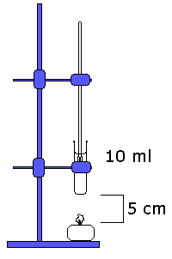
Results
 | Mass of candle (g) | Temperature (⁰C)
Start
End
Difference
Other Observations
Word equation
→
Experiment 15: Rates of Reaction to be written up as a Formal Report
Date Co-workers

Introduction
Write a brief summary of what you had been told in class or had read in your textbook about the factors affecting the rate or speed of reactions. This will form the basis of the Aim and Hypothesis (what you thought would happen) in your report.
Materials and methods
4 pieces of marble about the same size (~ 1 cm) for parts 1 and 2
2 pieces of chalk about 1 cm long, with one cut into smaller pieces but not crushed
1.0 M Hydrochloric acid (HCl)
0.5 M HCl (contains less acid than 1.0 M)
10 or 20 mL measuring cylinder
A 100 mL beaker containing hot water to be a ‘mini water bath’ for tube
Thermometer
Safety Considerations especially SAFE DISPOSAL

1. The Effect of Temperature
- Choose two pieces of marble that are about the same size and shape  - Set your test tubes up as shown  - Add 5.0 mL 1.0 M HCl to both tubes  - Sit your tube B in a little beaker of hot water  - Use a thermometer to measure the temperature in tube B  - When the temperature of tube B has increased by 10 or more degrees add a marble chip to each tube  - Observe how fast the bubbles form and record this in the results table | 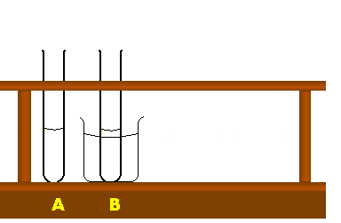

2. The Effect of Concentration
- Please Note: 1.0 M HCl is more concentrated than 0.5 M HCl  - Place two more test tubes C & D in your test tube rack.  - Find two more similar pieces of marble.  - Add 5.0 mL 1.0 M HCl to tube C  - Add 5.0 mL 0.5 M HCl to tube D  - Carefully drop the marble chips in each tube, and record the bubble rate | 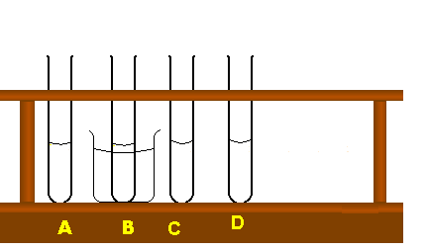

3. The Effect of Surface Area
- Add two more tubes to your rack  - Add 5.0 mL of 1.0M HCl to each tube  - Take two pieces of chalk the same size  - Cut one into small pieces into smaller chunks, but don’t completely crush it  - Add the piece of chalk to tube E & the smaller bits to Tube F at the same time  - Record the bubble rate | 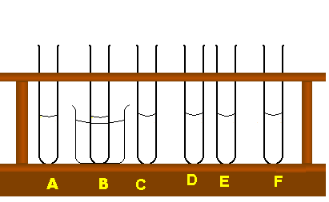
Results
Complete the table of results
 | Conditions | Reaction Rate and other Observations
A | 5 mL of 1.0 M HCl at room temperature with 1 cm piece of marble
B | 5 mL of 1.0 M HCl at increased temperature with 1 cm piece of marble
C | 5 mL of 1.0 M HCl with 1 cm piece of marble
D | 5 mL of 0.5 M HCl with 1 cm piece of marble
E | 5 mL of 1.0 M HCl with 1 cm piece of chalk
F | 5 mL of 1.0 M HCl with 1 cm piece of cut up chalk
Note: Pieces for A & B must be similar, and pieces for C& D must be similar
Discussion and conclusion

Include a description of any problems you had and ideas about ways the experiment could be done better.
Use diagrams such as the one below to help you explain your observations.
X X X
OOO
X OOOO X
OOOO X

Smaller pieces of Chalk + Hydrochloric acid
Whole piece of Chalk + Hydrochloric acid

O Chalk
X Hydrochloric acid (HCl)
Use similar diagrams to explain any difference in the reactions between chalk pieces of the same size and heated and non-heated 1.0 M HCl and any difference chalk pieces of the same size and 0.5 M HCl and 1.0 HCl.

State a conclusion or conclusions to your experiment.
Expanding table

Experiment 16: The Effect of a catalyst on the rate of a reaction. Demonstration

Materials
- Concentrated Hydrogen peroxide H₂O₂
- Manganese Dioxide MnO₂
- Detergent
- 1L measuring cylinder
- safety gear (Lab coat, goggles, gloves)
- Tote box
Safety considerations
Wear Lab coats and goggles
The reaction releases a lot of heat. Students must stand well clear and do not touch the equipment or reactants before, during or after.

Method
- Add 2 tea spoons of MnO₂ to the measuring cylinder
- Add enough detergent to cover the MnO₂
- Add 100ml of H₂O₂ and stand back
- Observe what happens
Q1
Complete the word equation:

Hydrogen peroxide → Oxygen gas +
Q2 What was the catalyst in the observed reaction?
Q3 What effect did the catalyst have on the reaction?
Q4 what caused the detergent to froth up?
Q5 What was the black substance that was stuck in the froth?

Experiments: Formal Reports

Use the outline below to write reports on your experiments as your teacher asks you.
Insert new pages using the method described in the Journal section.

Date | The date you did the experiment
Names of co-workers

Title: | eg Title
Aim and hypothesis | You should be able to make up your own …  Tell the reader why you did the experiment, and what you expected to happen (this is your hypothesis)
Materials and Methods | Turn the list of the equipment and the instructions into sentences to describe how you did the experiment.  Write in past tense third person. E.g. The water was placed in a beaker  Draw a diagram.
Safely considerations | What safety risks existed?  How did you work safely?  How did you dispose of any chemicals or other waste safely?
Results | Describe what happened in words, and in table or graph form.
Discussion | Always  Our results showed …  Use any of the following that apply.  We had difficulty with/doing …  The experiment could be improved by …  Other experiments that could be done are …
Conclusion | Write a sentence here telling the reader if your results supported your hypothesis i.e. did what you expect to happen actually happen.  Is there a new hypothesis you could test?

Homework Activities

REMEMBER p. 3 States of matter
- What properties do we use to classify materials into the three states?
- Which state/s of matter:
  - Can be compressed?
  - Can flow?

THINK
- Classify each of the following items as a solid, liquid or gas.
  - Oxygen
  - Talcum powder
  - Glass
  - Vaseline
  - Oil
  - Honey
  - Wood
  - Sand
- Why is a bicycle frame made of solids?
- Why are bicycle tyres filled with air?
OBSERVE
- Look carefully at the circus scene in your book. List as many solids, liquids and gases as you can find.
REMEMBER p. 5 Changes of state
1. List the three states of matter.
2. Is heat transferred to a liquid or from a liquid during freezing?
3. What is the melting point of ice?
4. What is the boiling point of water?
5. Copy and complete the following flow diagram: (you can type over it or use arrows) or do the online Flash Activity.

THINK
6. What is the difference between evaporation and boiling?
7. Describe a method for changing the boiling point of water.
INVESTIGATE
8. at what temperature is:
(a) Oxygen a solid?
(b) Aluminium a liquid?
9. Find out how the melting point of water can be changed.
Based on Remember p.7 The particle model
1. List the four main points of the particle model of matter?
2. What is diffusion and how does the particle model help explain it?
3. Give an everyday example of diffusion at work.
4. Read and use the information on p. 6to complete the Solids, Liquids and Gases Venn diagram. Put the common properties in the overlapping areas, and the ones that are unique to each state in the non-overlapping areas.
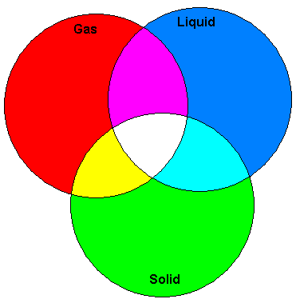
You can type over the diagram

THINK

5. Why do solids have a fixed shape?
6. Why can gases be compressed?
7. Why do gases fill their containers?
8. When you pour cordial into water, the two liquids slowly mix together even though you don’t stir them.
Explain how

Remember page 9 Change of state and the particle model

- What happens to the movement of particles as a substance changes from a solid to a liquid?
- What happens to the movement of particles as a substance changes from a gas to a liquid?
- Why do substances often expand when they are heated?

THINK
- The steel rails used in train tracks are placed end to end in a line to form each side of a train track.
- Gaps are left between the steel rails. Why do you think these gaps are left between the rails? Use the word ‘expansion’ in your explanation.
- What is the relationship between the amount of energy the particles in a substance have and the state (phase) of the substance?
- Explain why many substances contract when they are cooled.
BRAINSTORM
- Make a list of structures and substances around your home that undergo expansion and contraction.
- Checkpoint
Particles in motion
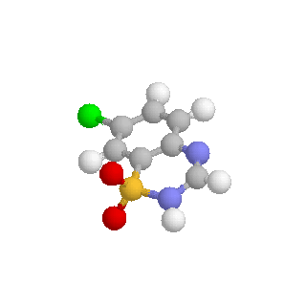

- Summarise your understanding by filling in the following table. Draw diagrams and use words such as, least, medium, most, or closest, medium, farthest.

 | Spacing of molecules | Energy of molecules | Example
Solid
Liquid
Gas

REMEMBER p. 15 Spaced out particles (gases)
- Why can gases be compressed?
- What happens to a gas that is heated?
- Explain how a carbon dioxide fire extinguisher works.
- Which special gas absorbs electrical energy to create the bright lights shown below?
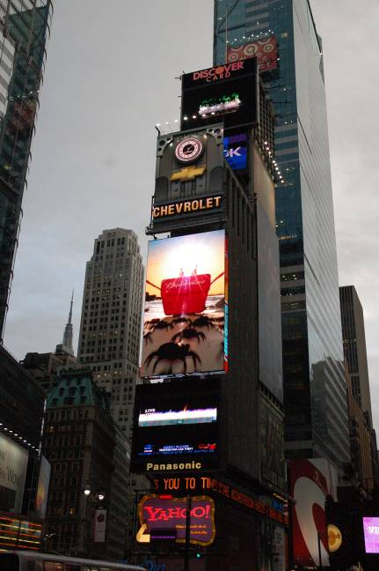

THINK
- Draw a diagram of a gas before and after heating to show what happens to the particles.
- Why do aerosol cans have ‘Do not dispose of in fire’ printed on the can?
- Explain which would last longer: a scuba diver’s tank filled with compressed air or one filled with air at normal pressure.
- Explain what would happen to the pressure in a car tyre after it has been driven on a hot road, and then parked on some cool grass.
INVESTIGATE: Digging Deeper
- Many gases, including oxygen, nitrogen, chlorine and hydrogen, have very important uses.
Choose one of these gases and find out what it is used for and why.
- Find out what gases are found in the air and how much of each gas there is.
- Many gases in the air are pollutants put there by humans. Find out about what problem one of the following gases causes for the environment:
sulphur dioxide, nitrogen dioxide, ozone or chlorofluorocarbons (CFCs).
Activities pp 12-13 Properties of Liquids

REMEMBER

- What is cohesion?
- How does an evaporative cooler work?
- What makes a lubricant like oil slippery?
- Explain how a hydraulic jack works.
- What property of liquids does a thermometer use?
- Why do liquids expand when heated?

THINK

- How are the particles in oil different to those in water?
- Explain why a liquid cannot be compressed.
- Why can’t gases be used in hydraulic machinery?
- What does it mean if a chemical can dissolve in water?

REMEMBER p. 17 What’s in an atom?

- What does the word ‘atomos’ mean?

- What is an atom?

- Name the three parts of an atom and explain where they would be found.

- Why do electrons not fly off an atom?

- What is an atom mostly made up of?

- What is a molecule?

- Give two examples of molecules.

THINK

- If a neutral atom has 12 protons, how many electrons will it have?

- Draw a diagram of a water molecule made of one oxygen atom and two hydrogen atoms?

- What is the difference between an atom and a molecule?

REMEMBER p. 19 Elements and Compounds
Term | Q 1 Meaning (May include a diagram) | Q 2 Example
Element
Compound
Mixture

If atoms are ‘bonded’ together, what does this mean?
How many elements are there in total? (Include man-made as well as naturally occurring ones)
What elements are present in carbon dioxide?
THINK
How can only 92 different elements make millions of different compounds?
Draw a diagram to show a mixture of water and carbon dioxide molecules.
CREATE
Build models of some compounds. You may have to work out how many of each type of atom there are in a compound and in what shape they are joined together.
INVESTIGATE: Digging deeper
Each element has a symbol. Find out what this means, and what the symbols of the first ten elements in the periodic table are.
CONNECT: Digging deeper
Find out more about the elements by studying the interactive periodic table linked to on the Intranet.
Activities p. 75 Chemical and Physical Changes Activities

REMEMBER
- List three types of physical change. Give an example of each type.
- How do you know that toasting bread is not a physical change?
- How do you know that dissolving salt in water is not a physical change?
- In your own words, write meanings for the following terms:
  - melting
  - condense.

THINK
- Complete this table by listing the type of physical change that occurs during each action.

Action | Type of Change
Mashing potato
Melting chocolate
Freezing ice blocks
Mincing meat
Chopping wood
Boiling water
Tearing paper into small pieces
Moulding plasticine

Activities p. 77 Chemical Changes

REMEMBER
- What always happens to the particles of a substance when a chemical change takes place?
- List four observations that indicate that a chemical reaction may have taken place.
- What is the only way to be sure a chemical reaction has taken place?
- The rusting of iron is a chemical reaction:
- What are the reactants?
- What is the product?

THINK

- The burning of natural gas requires heating before the reaction takes place. Why is heat not shown in the chemical word equation as a reactant?
- Dissolving is an example of a chemical change. Is it an example of a chemical reaction? Explain your answer.
- Write word equations for the following chemical reactions:
- Vinegar and baking powder react to form salt, water and carbon dioxide.
- Wood burns with oxygen to form carbon dioxide and water.

Activities p. 79 Precipitation reactions

REMEMBER
- What is a precipitation reaction?
- List the elements that are found in protein molecules. (See chapter 3)
- What are curds?
- What is an aqueous solution?
- Describe one property of all aqueous solutions.
THINK
- Why does a precipitate sometimes appear when two aqueous solutions are mixed together?
Activities p. 81 Taste sensations (acids and bases I)

REMEMBER

- We can eat and drink some acids. What do they taste like? Give an example.
- We can eat and drink some bases. What do they taste like? Give an example.
- List four reasons why acids are added to foods.
- What are the products of a chemical reaction between sodium bicarbonate and an acid?
- Which gases cause a cake to rise during the baking process?
- Why don’t the acids and the base in baking powder react while they are in the tin?

THINK

- Baking powder contains sodium bicarbonate and sodium hydrogen phosphate.
- Is the chemical reaction between sodium bicarbonate and sodium hydrogen phosphate a neutralisation reaction?
Explain your answer.
- List at least two elements found in sodium bicarbonate.
- List at least three elements found in sodium hydrogen phosphate.

CONNECT

- Read the ingredients on the label of a tin of powdered fizzy drink. Make a list of the acids and bases used. Search the Internet to find out what elements are in the acids and bases.

INVESTIGATE: Digging Deeper
- Acids can react with metals. For example, hydrochloric acid reacts with sodium, cobalt, iron, nickel, chromium and zinc. These reactions always have two products.
- Use library resources to find out what these products are. Write a report that includes:
  - a general word equation for this type of reaction
  - a word equation for each reaction
  - a description of the colour and state of all the reactants and products.
Activities p. 83 Gut reactions (acids and bases II)

REMEMBER

- State one reason why chemical reactions take place in your digestive system.
- Which substance is broken down in your mouth?
- In a neutralisation reaction:
- What are the reactants?
- Which two substances are always produced?
- What does a chemical indicator do?

THINK

- Explain why enzymes are so important in the digestive system.
- Why does the stomach produce more acid when you overeat? What type of chemical reaction do antacids take part in to make you feel better?

CREATE: Digging Deeper

- Acid rain is a big problem in many countries. Find out how acid rain forms and the problems it causes.
Report your findings in a multimedia format such as a PowerPoint presentation.

INVESTIGATE: Digging Deeper

- When ‘pool chlorine’ is added to water, an acid forms. Find out what the purpose of this acid is.
- What happens if too much acid is present in a swimming pool? What happens if there is not enough?
- Explain what indicators are and give examples of their use.

Activities p. 85 Combustion Reactions

REMEMBER

- What do all combustion reactions have in common?
- On a gas stove, where does the heat to start the reaction between methane and oxygen come from?
- Respiration is a chemical reaction that takes place in your cells.
- What are the reactants?
- What are the products?
- Which chemical product do all of the combustion reactions involving fossil fuels have in common?
- List five examples of fuels.

THINK

- What is the fuel in the combustion reaction that takes place in every cell of your body?
- Hydrogen and oxygen are cooled down to turn them into liquid fuels for the space shuttle. Why is water, the product of the reaction, produced as a gas?
- Write word equations for the following reactions.
- Sugar burns with oxygen to form carbon, carbon dioxide and water.
- Baking powder reacts with vinegar to form carbon dioxide, water and salt.

INVESTIGATE: Digging Deeper
- Find out what fossil fuels are and what problems are associated with their use.
- How are each of the following fossil fuels formed and treated before use?
  - Methane
  - Kerosene
  - Octane
- Activities p. 89
REMEMBER

- List four ways to change the rate of a reaction.

- What is a catalyst?

- How do you know that a catalyst is not a reactant?

- What makes enzymes different from other catalysts?

- Which chemical in the air reacts with substances in fruits to make them go brown?

THINK

- Food keeps well in a refrigerator. Explain why it keeps even longer in the freezer compartment.

- Aspirin tablets contain a solid acid and a solid base. The acid and the base react when the tablet dissolves in water.
- How could you make the reaction between the acid and the base happen more quickly?

- Why does the word enzyme appear over the arrow in the chemical word equation for the browning of fruit?

Activities p. 87 Reactions with Light

REMEMBER

- Write a chemical equation for a reaction that:
  - Releases light
  - Needs light in order to take place
- List four things that must be present for photosynthesis to take place.

THINK
- Why is it necessary to ignite fireworks in order for them to produce light?
- Why is photosynthesis described as the most important chemical reaction involving light?

CONNECT: Digging deeper
- Some plants and animals are able to produce light through chemical reactions that happen within them.
- This is called bioluminescence. Search the Internet to find information about an animal or plant that produces light energy.
- Report your findings in a multimedia presentation.
- Include information such as:
  - Where the animal or plant lives
  - The reason it produces light
  - How it produces light
  - The use humans make of this plant or animal.

